**Parallel, Series, and Complex**

**Systems.**

**Lab: 04**



Fall 2022

CSE-3L Control Systems

Submitted by: **Amir Suliman**

Registration No: **19PWCSE1805**

Class Section: **B**

“On my honor, as a student of the University of Engineering and Technology, I have neither given nor received unauthorized assistance on this academic work.”

Student Signature: ______________

Submitted to:

**Dr: Muniba Ashfaq**

November 9, 2022

Department of Computer Systems Engineering

University of Engineering and Technology, Peshawar

**Objectives:**

* To know about systems interconnection
* Parallel connection
* Series connection
* Complex connection

**Task 01:**

**Series Connection**

When the output of one system is the input of another system then the combination is called a series connection.

**Code of Equivalence:**

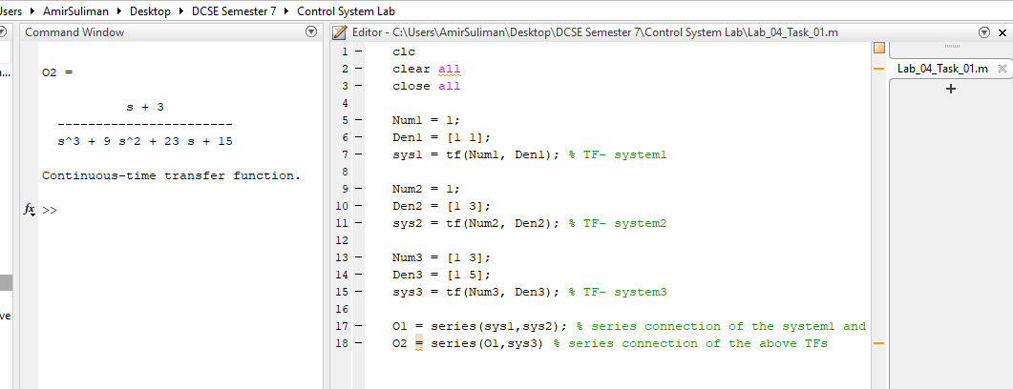

**Simulink:**

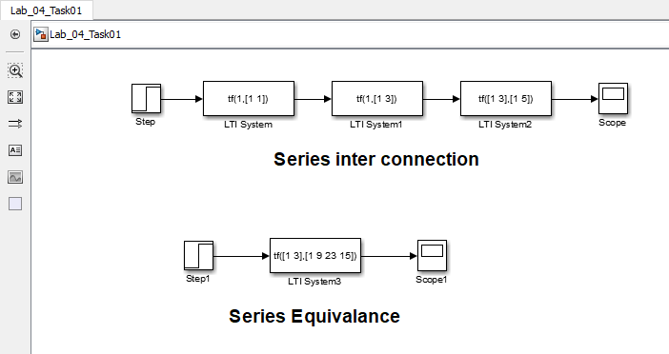

**Output:**

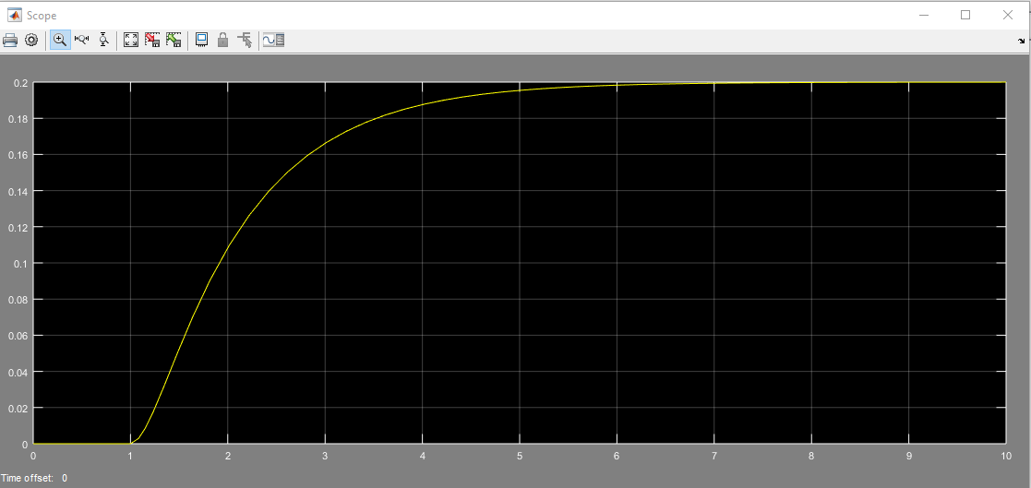

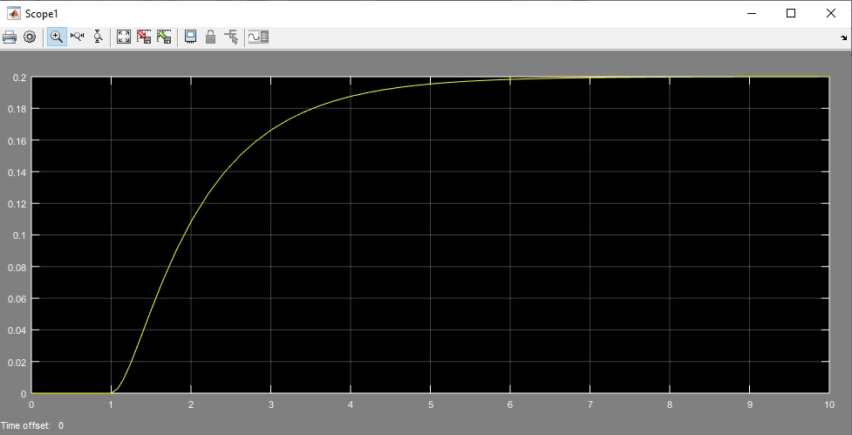

**Task 02:**

**Parallel connection**

In this connection, the two systems have the same input, while the output is the sum of the outputs of the two systems.

**Code of equivalence:**

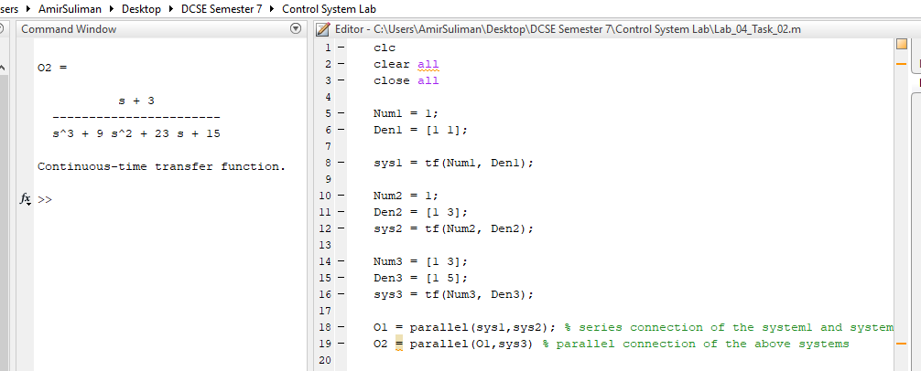

**Simulink:**

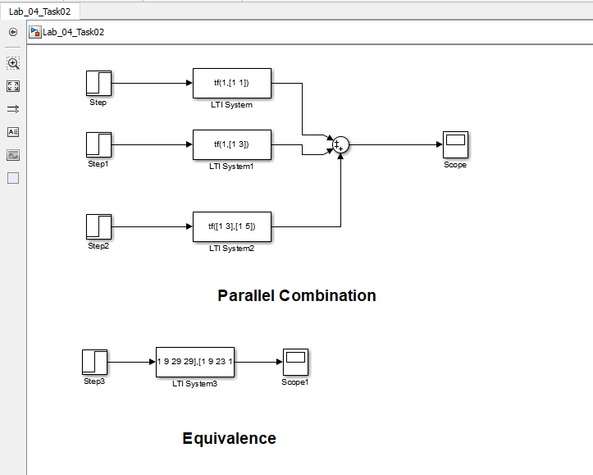

**Output:**

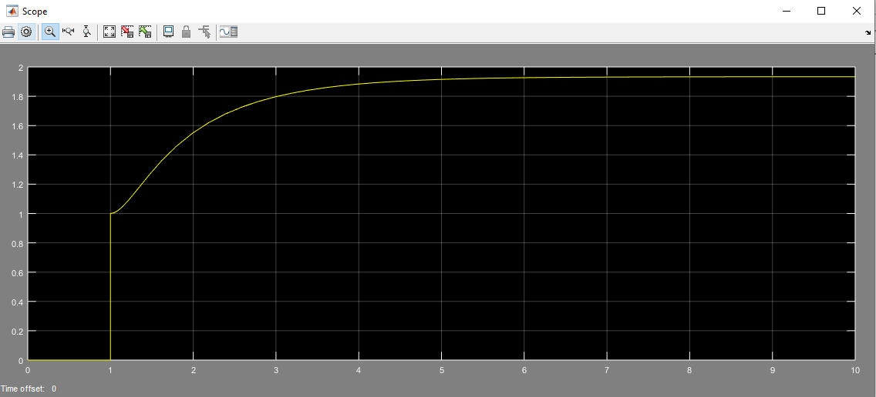

**Task 03**

**Complex Connection:**

The combination of parallel and series connections is called complex connections.

**Code of equivalence**

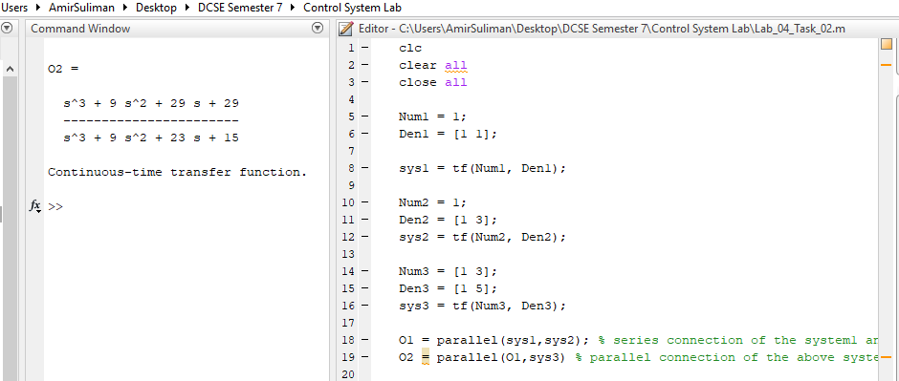

**Simulink:**

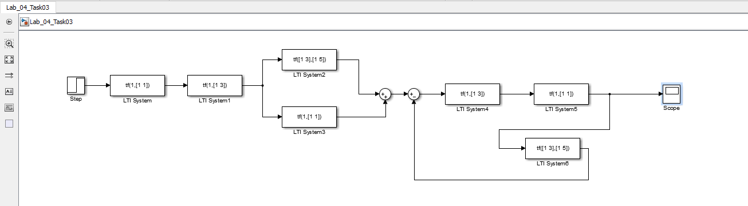

**Output:**

